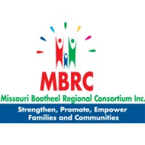
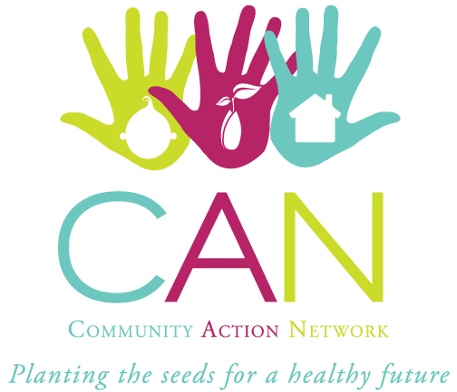

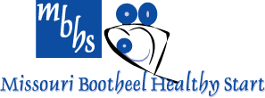

LOCAL COMMUNITY-BASED WORKFORCE
TO INCREASE COVID-19 VACCINE ACCESS
Serving Scott, Butler, Pemiscot, Dunklin, Mississippi, and New Madrid Counties
Vaccine Clinic for ages
5 -17 years old. Get a
$50 Gift Card on site!

January 14, 2022
Bowden Center
700 Sy. Williams Charleston MO 63834 4:00pm-6:00pm

TRANSPORTATION OPTIONS, DAYCARE REIMBURSEMENT, AND FUEL REIMBURSEMENT OPTIONS ARE AVAILABLE. TRANSPORTATION IS HANDICAP ACCESSIBLE. WHEELCHAIR ACCESSIBLE VAN AVAILABLE.
CALL MBRC AT 573-471-9400 FOR MORE INFORMATION.
LOCAL COMMUNITY BASED WORKFORCE TO INCREASE COVID-19 VACCINE ACCESS
Missouri Bootheel Regional Consortium, Inc.
905 S. Kingshighway Sikeston, MO 63801
Toll Free: 1-888-317-4949
www.mbrcinc.org

